Build a Private Subnet
By Haroon Zaman | November 2025

Introduction
I completed this project to deepen my understanding of AWS networking and secure cloud design. After building a public subnet and enabling internet access, my goal was to learn how to create a private network inside AWS where resources are not exposed to the internet and can only communicate internally.
This step is essential for hosting secure resources such as databases, backend services, or internal applications.
In this project, I completed the following tasks:
- Created a Private Subnet – A subnet that does not provide internet access, ensuring security and isolation for internal resources.
- Created a Private Route Table – I set up routing rules so that resources in the private subnet only communicate within the VPC.
- Created a Private Network ACL – I added extra security to control inbound and outbound traffic using allow/deny rules.
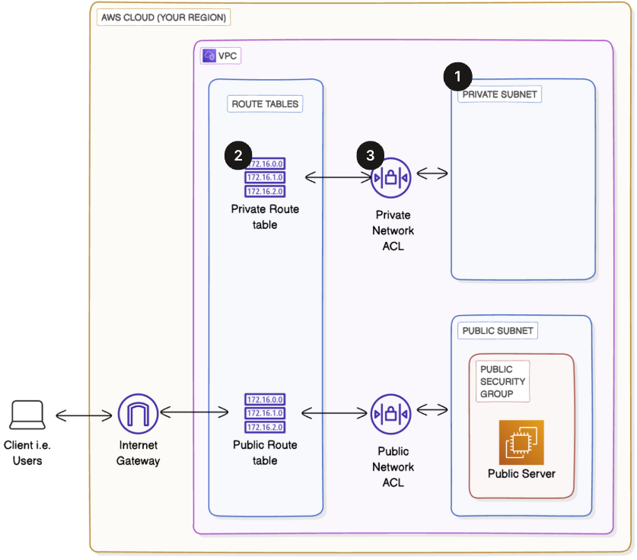

Private Subnet
A private subnet is a subnet inside a VPC that does not have direct access to the internet. It is used to host services that should remain internal and secure—for example, databases or backend servers that should not be publicly reachable.
Unlike a public subnet, a private subnet does not route traffic to an internet gateway.
To build my private subnet, I had to:
- Select my existing VPC.
- Define a new IPv4 CIDR block for the private subnet.
- Ensure that no public IPs are automatically assigned.
- Create a private route table that prevents internet access.
- Add a custom network ACL to control inbound and outbound traffic securely.
This setup helps maintain strong security and teaches how real-world cloud architectures separate public and private resources for best practices.
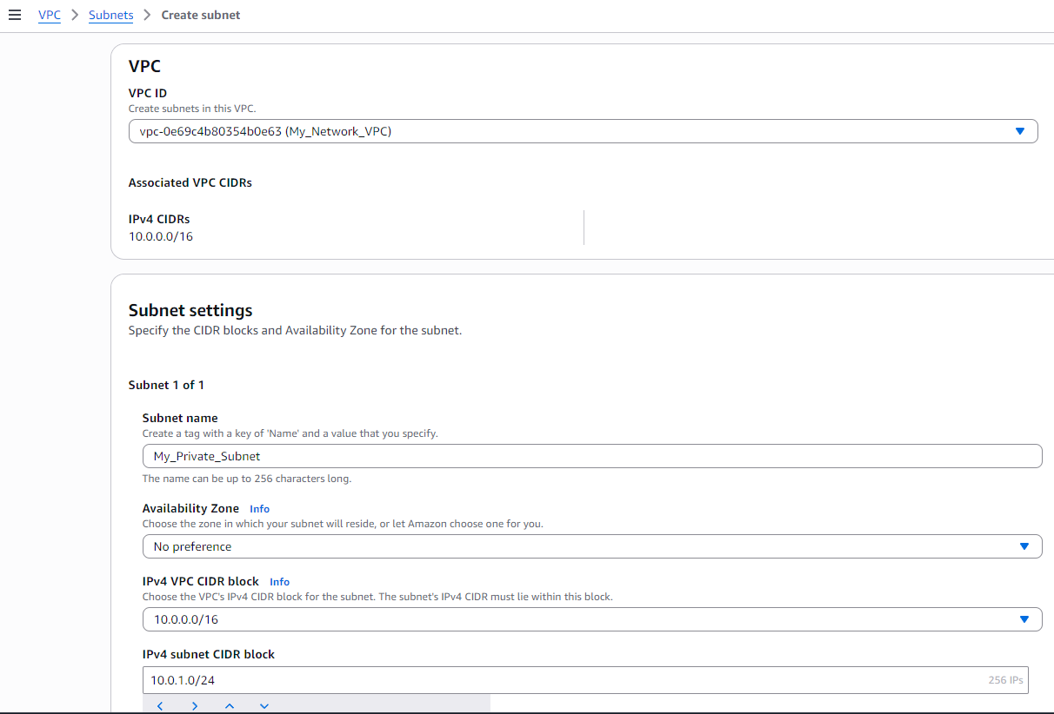
First, I went to the VPC console and selected Subnets from the left panel. Then I clicked on Create subnet.
- I selected my existing VPC: MY_NETWORK_VPC.
- I named the subnet My_Private_Subnet.
- For Availability Zone, I chose No Preference, which allows AWS to automatically assign a zone.
- In the IPv4 subnet CIDR block, I used 10.0.1.0/24, which is part of my main VPC CIDR range (10.0.0.0/16), ensuring the subnet stays within the VPC network.
After configuring these settings, I clicked on Create Subnet to successfully create my private subnet.
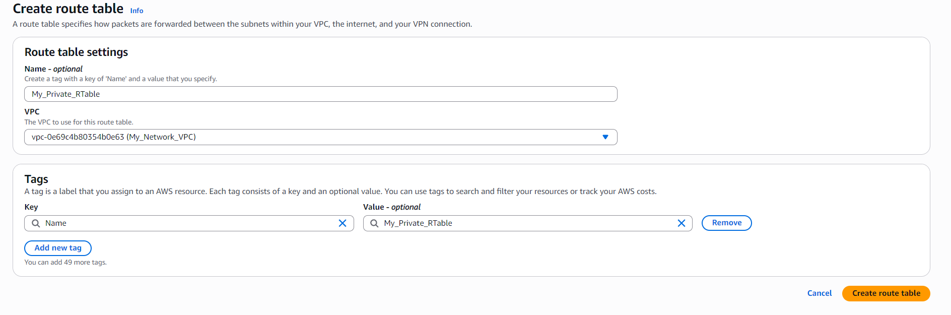

Creating a Private Route Table
After creating My_Private_Subnet, I proceeded to set up a private route table for it.
I opened the VPC console and selected Route Tables from the left-side panel. Then I clicked on Create route table.
- I named it My_Private_RTable.
- I selected my VPC: MY_NETWORK_VPC.
Once the details were filled, I clicked Create route table to complete the setup.
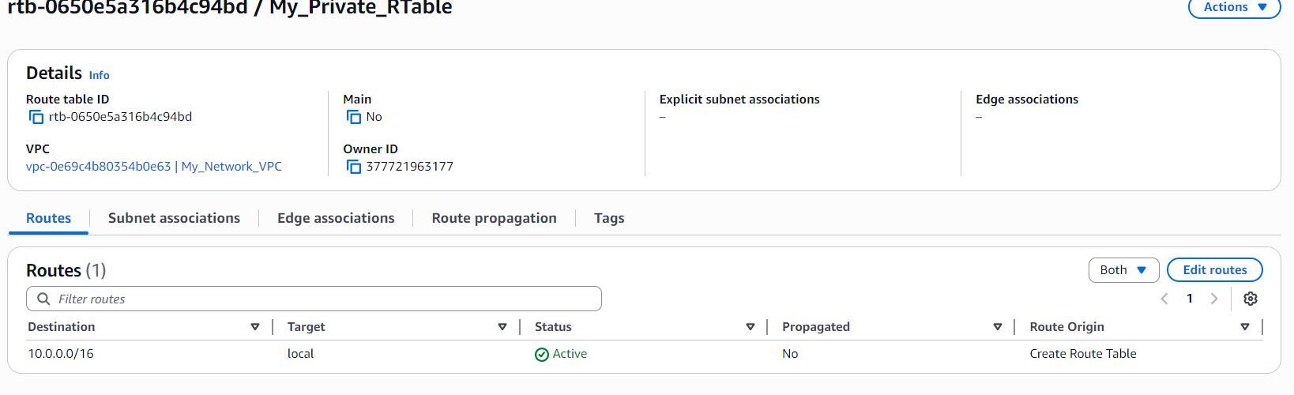

After creating My_Private_RTable, I checked the routes inside it. I noticed that there was already a default route with Destination: 10.0.0.0/16 and Target: local.
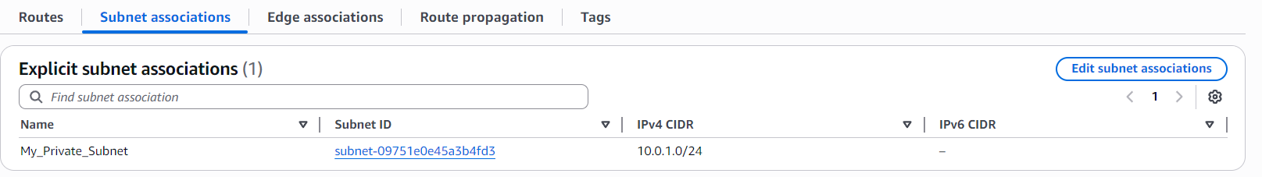
I selected My_Private_RTable, went to the Subnet Associations tab, clicked Edit associations, and selected My_Private_Subnet. After saving, the subnet was officially using this private route table — confirming it as a private subnet with no internet access.

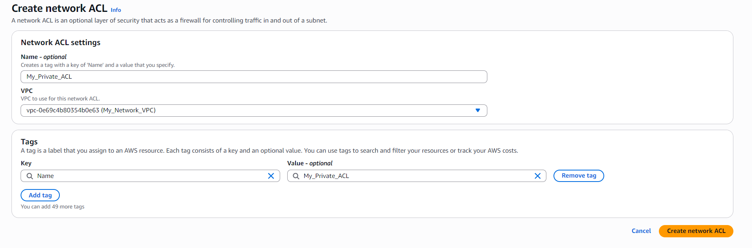

Creating a Private Network ACL
- Next, I created the private ACL for my subnet.
- In the VPC console, I went to Network ACLs and clicked Create Network ACL.
- I entered the name My_Private_ACL.
- I selected the appropriate VPC (MY_Network_VPC).
- Finally, I clicked Create to finish the setup.
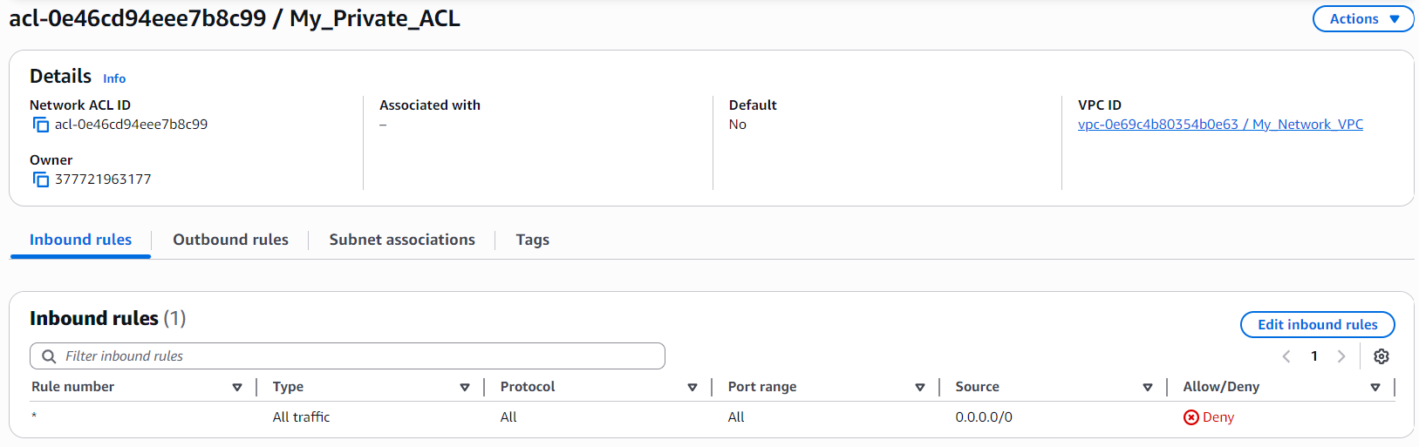
- After creating the My_Private_ACL, I reviewed the rules section.
- Both the inbound and outbound rules were set to DENY by default.
- I did not modify any rules because this subnet is meant to be fully private.
- Later, if I deploy resources inside this subnet, I will add rules according to my needs.
- For now, the subnet remains fully isolated and not accessible from the internet — which is the purpose of a private subnet.
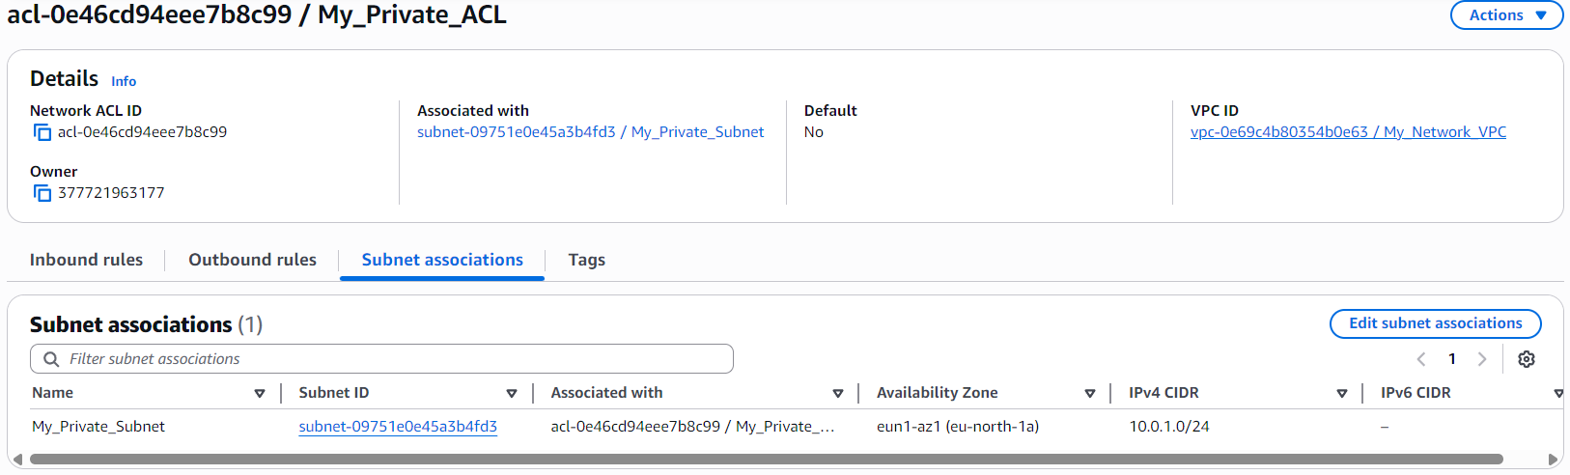
- After creating the My_Private_ACL, I went to the Subnet Associations tab.
- I clicked on Edit subnet associations.
- A list of subnets appeared — from there, I selected My_Private_Subnet.
- Then I clicked Save to confirm the association.
- Now, My_Private_Subnet is protected by my custom Private NACL, keeping it fully secure and isolated.

Conclusion
Through this project, I successfully created a private subnet, a private route table, and a custom network ACL, strengthening the security of my VPC. This helped me understand how resources can be fully isolated from the internet while still existing inside the same VPC. I also learned the difference between public and private subnets, and how routing and access rules control communication in AWS.
Working with custom ACLs and route tables gave me hands-on experience with network segmentation, access control, and secure architecture design. This project taught me how to build a secure cloud environment, preparing me for more advanced AWS networking and real-world cloud deployments.

